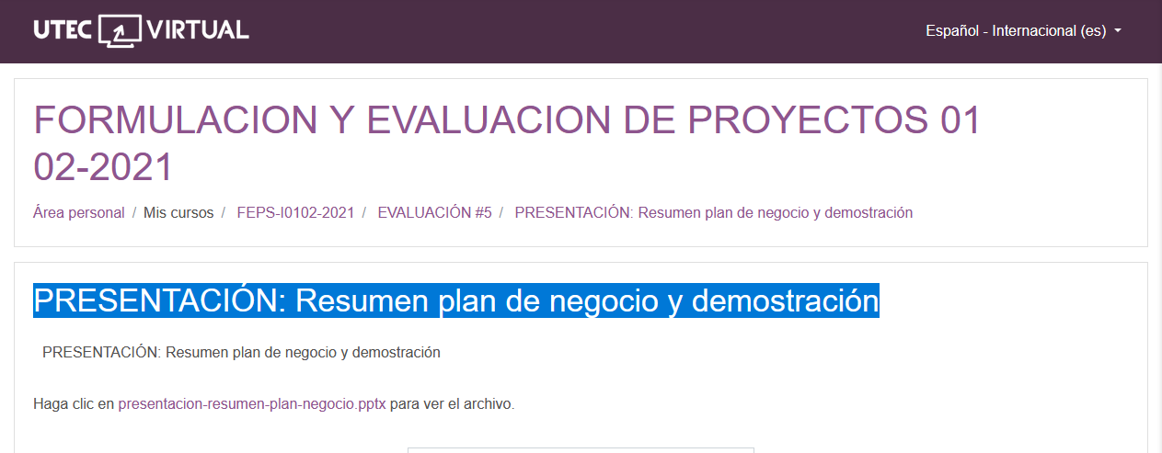

[presentacion-resumen-plan-negocio.pptx](https://uv.utecvirtual.edu.sv/salonv/pluginfile.php?file=%2F403411%2Fmod_resource%2Fcontent%2F1%2Fpresentacion-resumen-plan-negocio.pptx)